Meeting 23
Course / Class #: CECS 4800

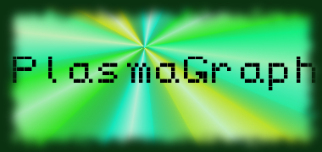
Date: 20 March 2014
Project Name: PlasmaGraph

Has been done:
- Implemented some requests by the client.
a. Auto-graphing changes. (Still has some problems, and lacks both automatic disabling of possible options based on chart type and some error messages.
  - Tests regarding maximum file sizes. (Handles 100 column x 68,400 row files (~60 MB MAT file) very quickly.)
2) Removed various unneeded or debilitating features, or moved things around. (DataFilter, multiple Graph queue, old / unneeded MVC classes.)
3) Start updating Data, Template, etc. SDD diagrams.
4) New GUI. (Two windows (Heavily considering putting graphs in a side-panel directly attached to settings), and graphs update automatically on second window.)

What will be done:
1) Bug fixing. (Outlier scanning is not removing outliers found and is mis-reporting outliers found; Auto-graphing isn't responding well enough to setting changes (Changing all setting listeners to FocusListeners so as to change upon switching from one setting to another); interpolation algorithms not graphing (Interpolation isn't providing the correct data to the Graphing classes?); edge cases with graphing (Sometimes, incorrect graphs appear or unhandled nulls are thrown.) )
2) Perform File size limit testing for CSV files, and update SRS with file processing times for large file sizes.
3) File size limit testing. (csv)

Materials Used: 2x Computers, Internet connections, Microsoft Visio / Dia (Diagramming Tools), Eclipse / NetBeans IDE (Programming Tools).

Group Members: ________________________________
Gerardo A. Navas

________________________________
Daniel Quintini
Professor:

________________________________
Prof. Luis A. Ortiz

